Terraform Task:02

1). Execute all the templates shown in the video.
Using two providers in a same configuration file
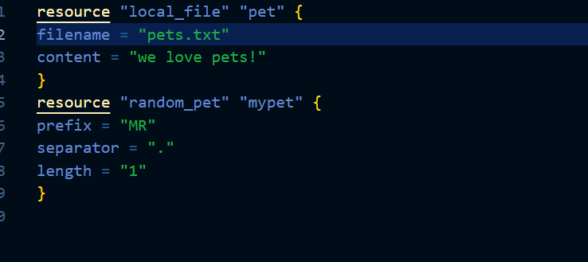
initializing backend : terraform init
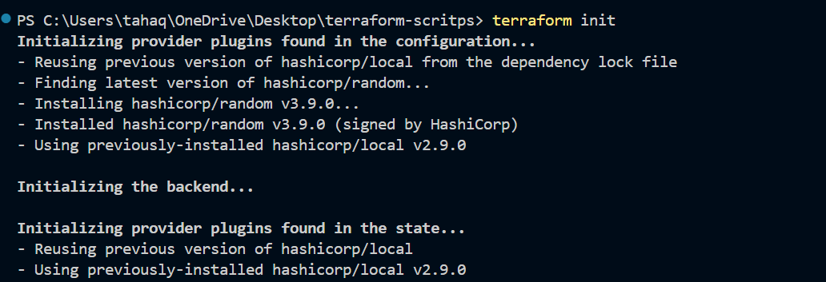

Now lets do terraform plan
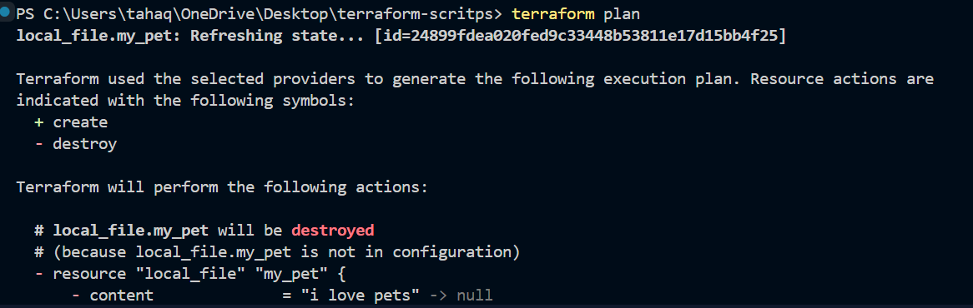

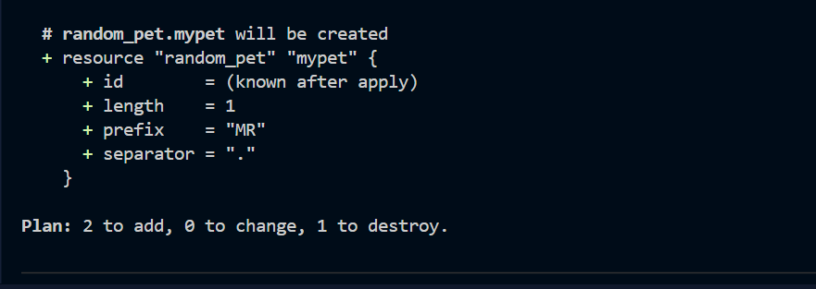
Here terraform is saying two things to add and it will destroy the existing one as by default terraform works on immutable infrastructure strategy
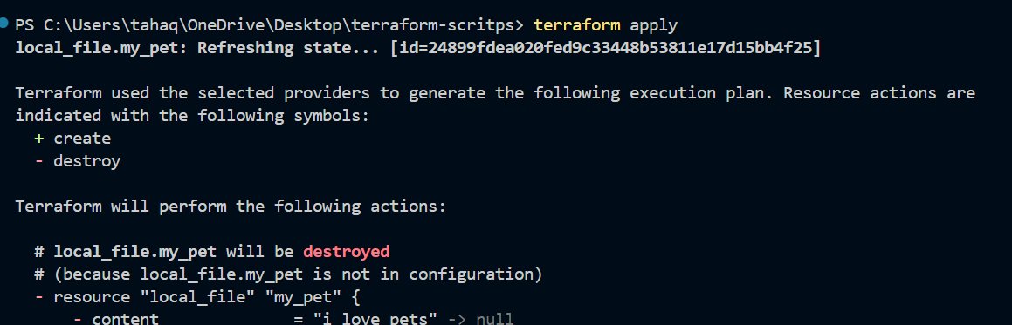
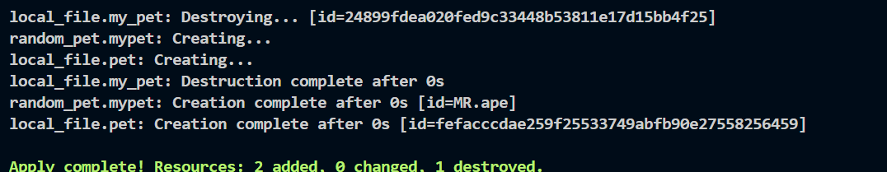
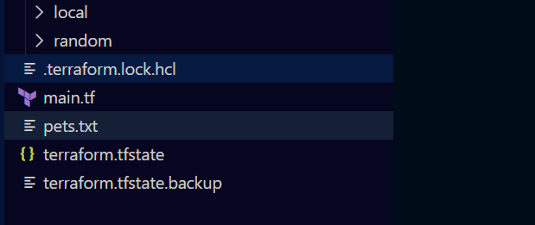

Pets.txt has been created and content inside is we love pets
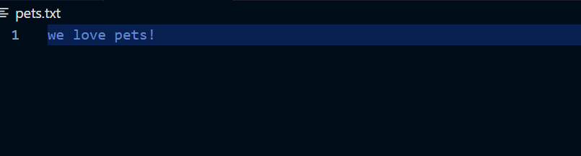

Lets work with the variables
Lets create a variables.tf file
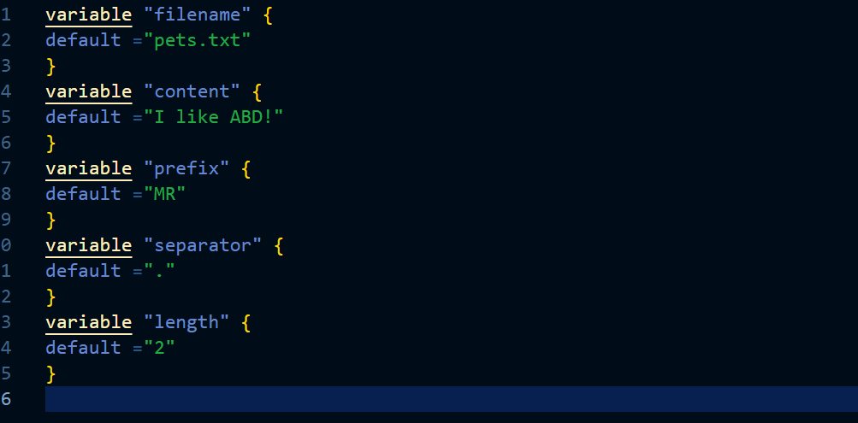
We have created a variables.tf file so instead of hardcoding the values inside our main configuration file we will be referring to this variable.tf file inside main.tf file
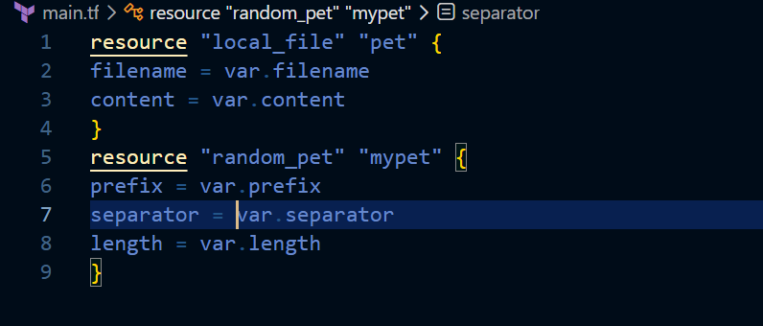
This is our main.tf now
Here we are using the variables var.filename , var.content etc from the variables.tf file
Lets now apply the changes
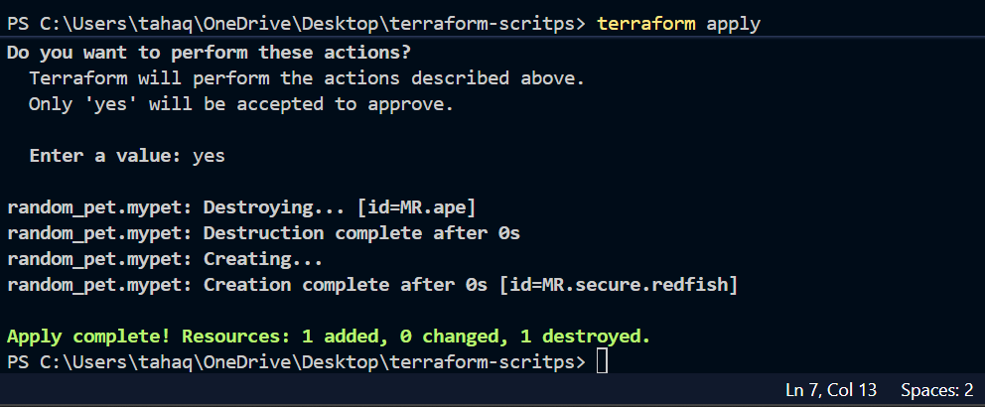
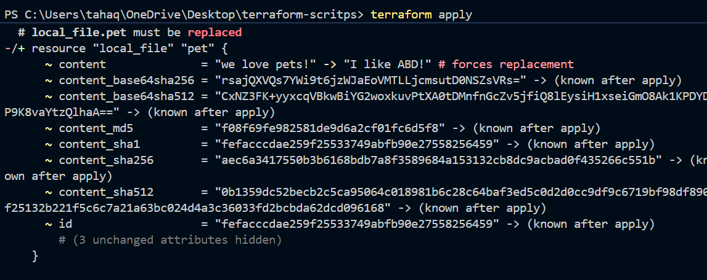
The content of the file has been changed here and terraform has deleted the existing file and created new one.

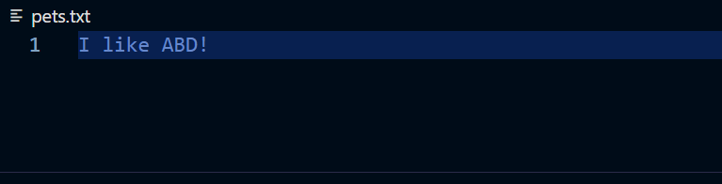

Lets now use the variables at the run time
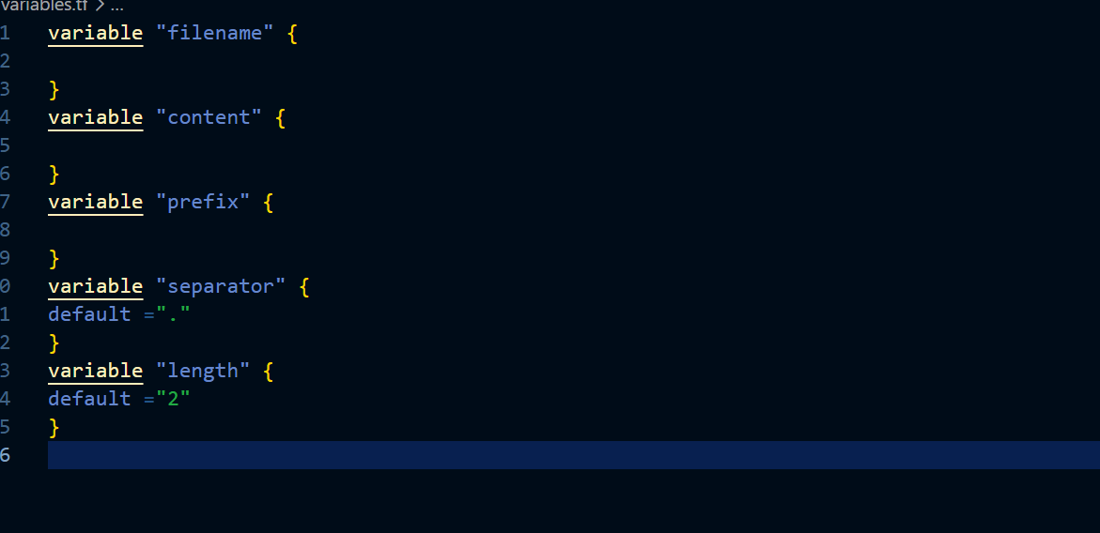
Here we can see that we have only declared variables and did not pass any value to them
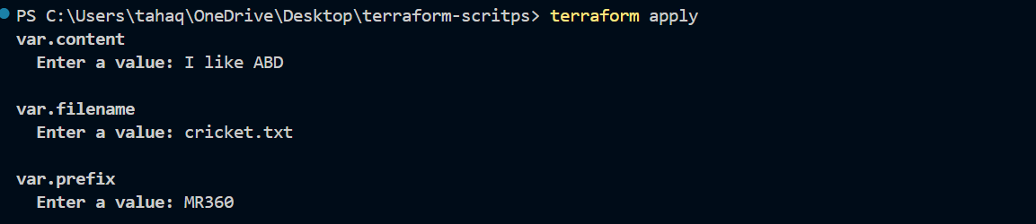
Here I have passed values at the runtime
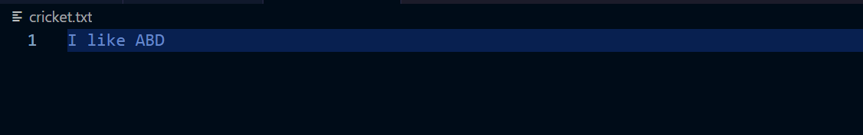
The file has been created with name cricket.txt
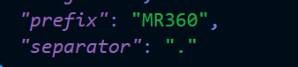

3). Integrate Terraform in Jenkins using the Terraform plugin.
Lets go to our Jenkins server and install terraform plugin
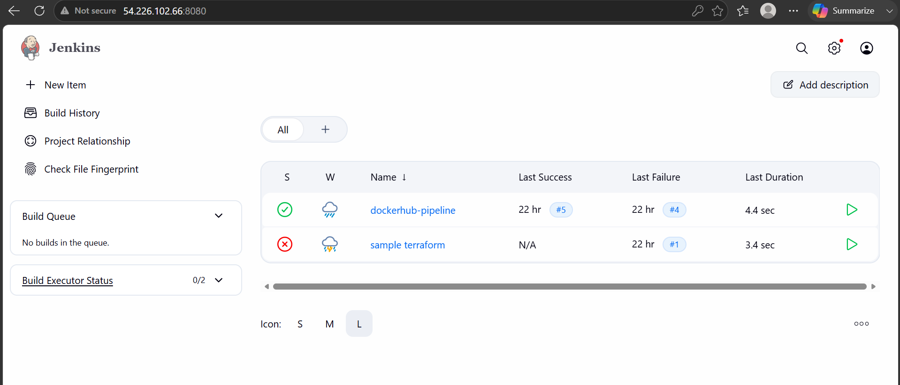

We are now logged in to Jenkins server lets install the terraform plugin
Go to manage Jenkins and plugins
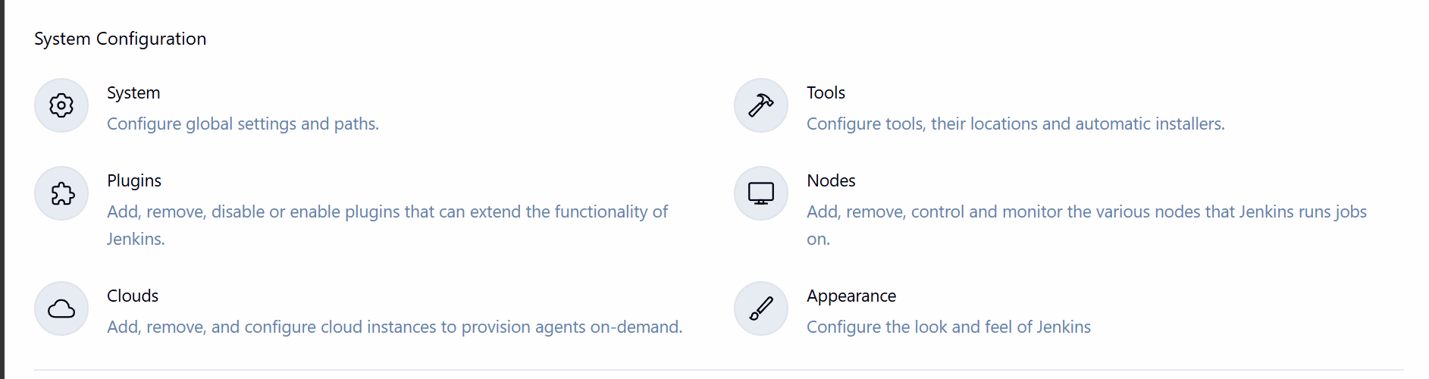
In available plugins search for terraform
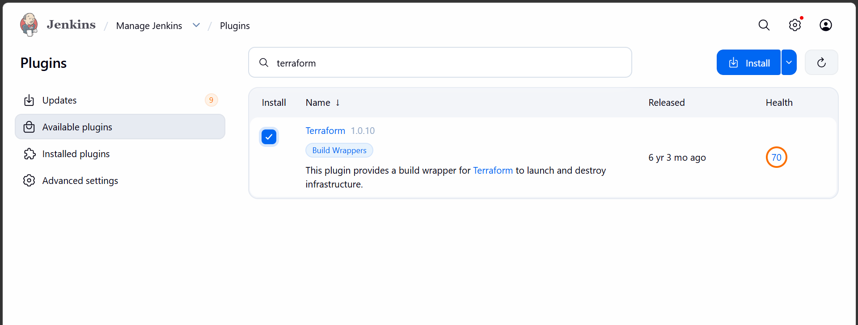
Add terraform installer in tools
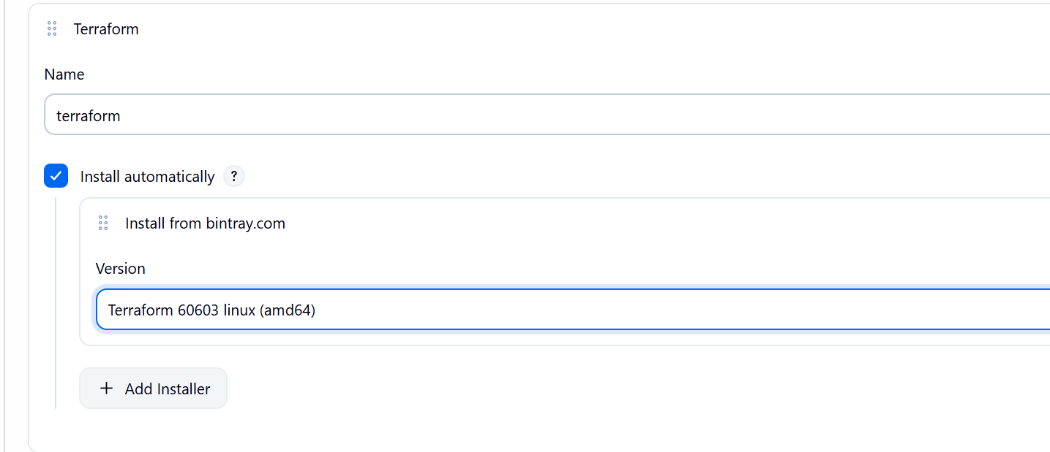

Create a pipeline job
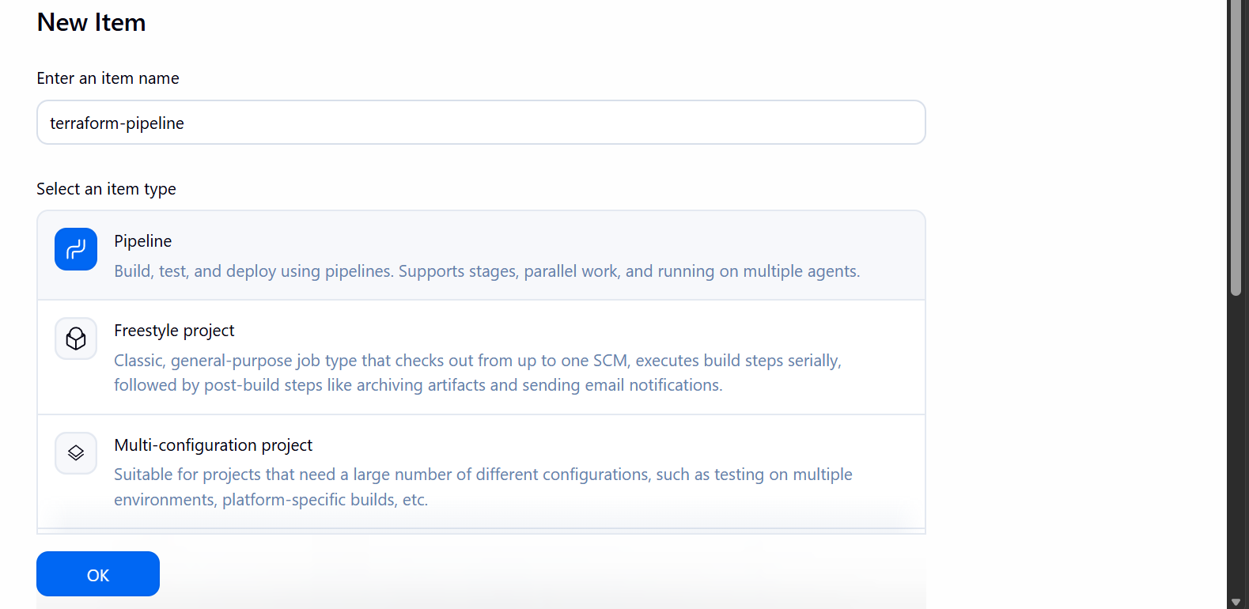
This is our main.tf file
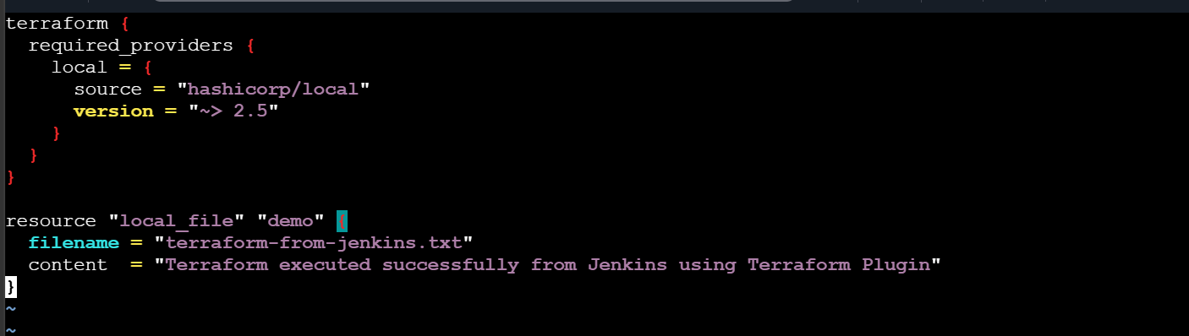
We have to keep it in the Jenkins workspace folder

Lets now run the pipeline script
pipeline {
agent any

tools {
terraform 'terraform'
}

stages {

stage('Terraform Version') {
steps {
sh 'terraform version'
}
}

stage('Terraform Init') {
steps {
sh 'terraform init'
}
}

stage('Terraform Plan') {
steps {
sh 'terraform plan'
}
}

stage('Terraform Apply') {
steps {
sh 'terraform apply -auto-approve'
}
}
}
}

The pipeline ran successfully
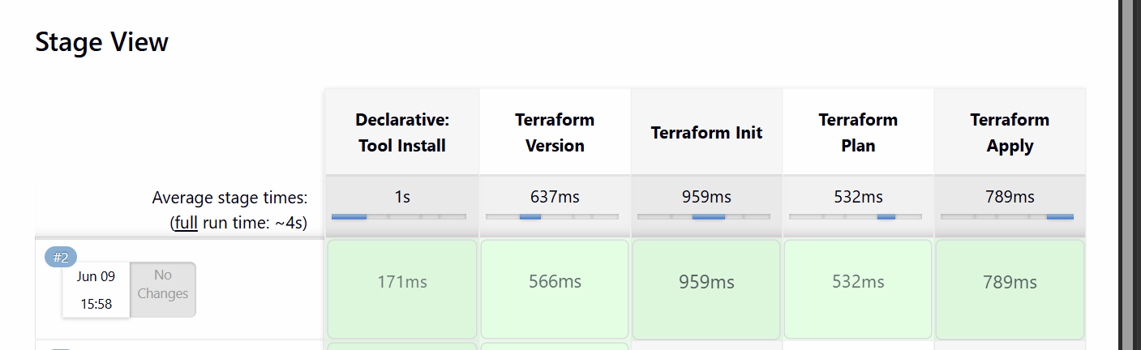
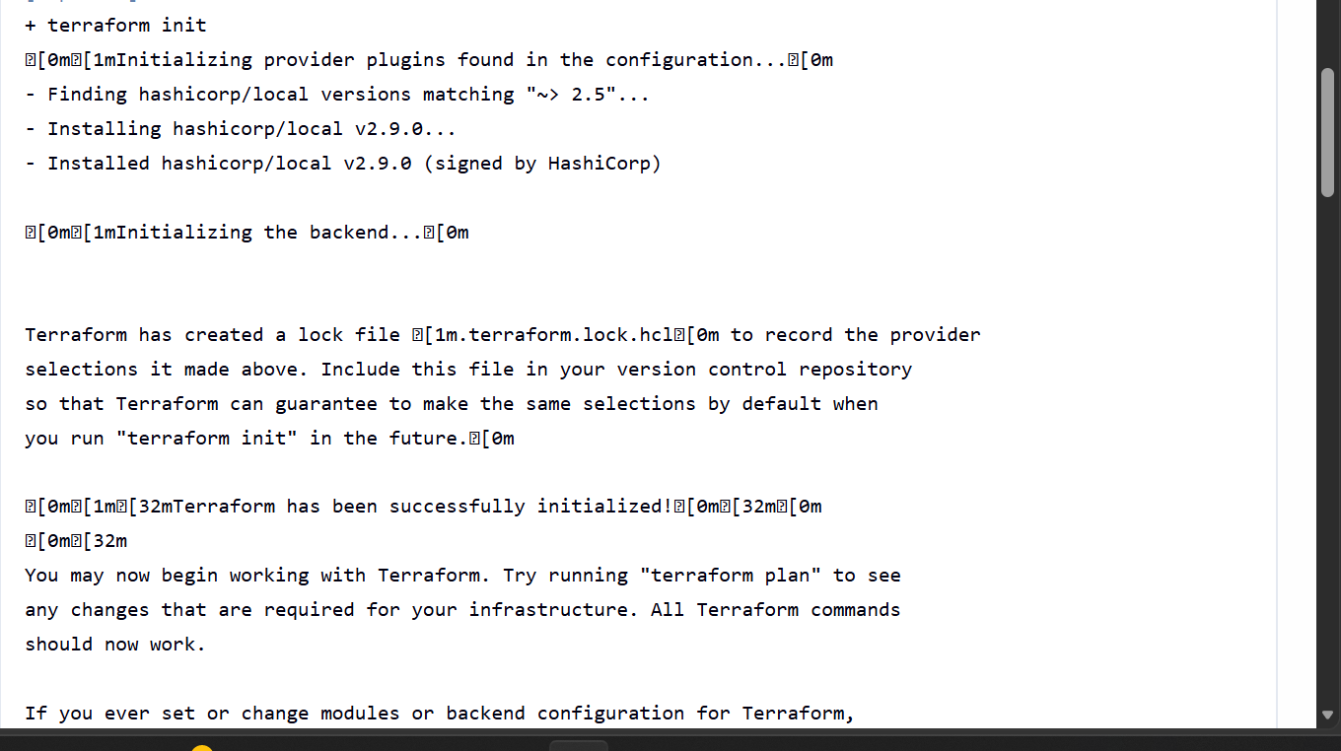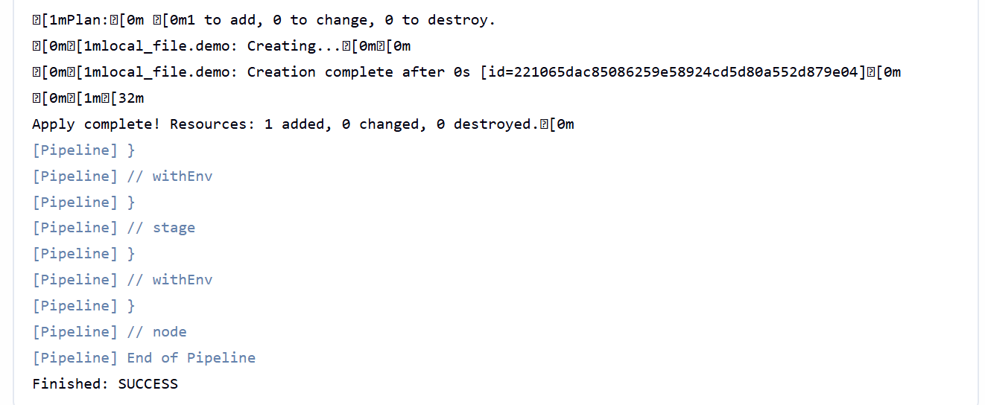
We can see the file is been created in Jenkins workspace folder

A local file named terraform-from-jenkins has been created with the below content
